American International University-Bangladesh (AIUB)

**Department of Computer Science**

**Faculty of Science &Technology (FST)**

**Fall 22-23**

**Educational Management System with Portal and Online Class Facilities**

Software Requirement Engineering

Sec: **B**

Project submitted

By

***Md Aminul Islam (Student ID: 19-39449-1)***

***Neehal Alam (Student ID: 19-39435-1)***

**Checked By Industry Personnel**

Name: **Mahedi Hassan**

Designation: **Assistant Project Manager**

Company: **Apsis Solutions Limited**

**Table of contents:**

1. **PROBLEM DOMAIN …………………………………………………4**
   1. **Background to the problem……………………..……………………………4**
   2. **Solution …………………………………………………………………4**
2. **SOLUTION DESCRIPTION …………………………………………5**
   1. **System features …………………………………………………………...5**
   2. **Functional requirements ……………………………………………………6**
   3. **Quality attributes ………………………………………………….……...8**
   4. **UML Diagrams ………………………………………………………..….9**
3. **SOCIAL IMPACT ……………………………………………………12**
4. **DEVELOPMENT PLAN WITH PROJECT SCHEDULE ………..12**
5. **MARKETING PLAN ………………………………………………...14**
6. **COST & PROFIT ANALYSIS ………………………………………15**
7. **REFERENCES ……………………………………………………….18**

**System Specifications**

|  |  |
| --- | --- |
| **Component** | **Minimum Requirement** |
| **Software Specifications** | |
| Text editor | Sublime Text |
| Programming language | PHP version 7.2< |
| Database | Microsoft MySQL server management studio |
| Browser | Internet Explorer 9.0<  Firefox 45<  Chrome 48 |
| **Server specifications** | |
| Processor | Core i5 8th generation |
| RAM | 4gb |
| OS | Windows 10,11, Linux, Mac Os,Android |

**1.** **PROBLEM DOMAIN**

**1.1** **Background to the Problem**

All educational institutions must deal with a lot of information, including student admission records, personnel records for hiring employees, and course-related data.

It becomes difficult to keep track of all of this data, which involves searching, updating, deleting, and adding. It could also be difficult to keep up with the employee curriculum at the institution. The student uses the portal to sign up for any course. When a student needs to pay their fees, they use the website similarly. Students must log in to their portals to view their grades or browse the notes that their professors have uploaded.

Let's say, for instance, that a student needs to have access to any institution-used virtual platform to register for a certain class. Several other tools are used simultaneously to perform various tasks. Because all the necessary tasks or features are scattered, maintaining the entire management system is difficult and time-consuming.

**1.2** **Solution to the Problem**

Our proposed solution might help to facilitate this in the future.

To bring all the facilities under one roof, admins and other authorities can maintain track of all the information that is efficiently and correctly stored by using this management system. It is possible to search, update, add and delete any data required easily and quickly. In doing so, immediate and necessary steps can be easily taken if an issue occurs. By introducing our proposed solution, students can very easily register for courses, pay their fees, join classes, browse their grades, etc. On one specific platform. All employees and faculty benefit from this since they no longer have to use multiple applications to complete various tasks. This also helps to maintain the discipline of the management system. Our software is complete Dynamic Academic Institution Management software, which

Is user-friendly Web Based Software. The special feature we are providing is immediate notifications for every real-time event which will be notified for all. It can provide support around-the-clock, which will be helpful to students who need assistance.Microsoft Teams, PraxiSchool, and iGradePlus are some of the current software options available to address the aforementioned issue.

**2.** **SOLUTION DESCRIPTION**

**2.1 System Features**

**2.1.1 Admin:**

* Any newly accepted students or workers can be added by the administrator to the institutional portal and virtual platforms. The admin has the ability to set a user ID and password for the organizational mail.
* The administrator can search for and edit any information that needs to be found or changed.
* Any unneeded data that is no longer needed can be deleted by the admin.
* According to their respective departments, administrators can open up course sections for students’ registration.

**2.1.2 Faculty:**

* Faculty members can design classes and give students access to those classes within the allotted period.
* Faculty may also design tests and particular assignments for students to complete virtually.
* The faculty can publish grades, notices, and other information on this platform so that students can keep track of their outcomes without even going to their organizational site.

**2.1.3 Student:**

* Through this tool, students can simplify their learning processes. They have access to take classes that their professors design for their specific section.
* Students can participate in tests and turn in assignments online.
* Students can read the faculty's public notices and grades.
* During registration, students can add course credits that have been created by the admin.
* They can also pay their semester fees online through this platform.

**2.1.4 Accountant**

* The finances and accounts of each individual student can be managed by accountants.

**2.2 Functional Requirements**

**2.2.1 System Login**

* The system enables users to log in with their given username and password.
* If the username or password has been entered incorrectly more than three times, a random verification code is generated by the system to retry logging in.
* If you exceed the number of login attempts (5 times), the system will block your account for one hour.

**Priority Level: High**

**Precondition:** The user must have a valid user ID and password

**2.2.2 Creating profile**

* Admin will be able to create new profiles of users with the software.
* If the ID number of the profile is the same as any other profile the software will notify and show errors while logging in.

**Priority Level: High**

**Precondition:** The user must be logged in as an administrator.

**2.2.3 Updating data**

* The software shall allow users to update any information.

**Priority Level: High**

**Precondition:** The user must be logged in as an administrator

**2.2.4 Searching data**

* Admin will be able to search for information about the desired item using the software.
* If the search data is not present, the software will display an error message.

**Priority Level: High**

**Precondition:** The user must log in as an admin.

**2.2.5 Deleting data**

* The software shall allow the admin to remove the desired information.
* The software will show a not-existing notification if the data the user wants to delete does not exist,
* The software will confirm whether the user really wants to delete it or not by showing a yes/no notification before deleting the data

**Priority Level: High**

**Precondition:** The user must be logged in as an administrator.

**2.2.6 Receiving feedbacks**

* Students will be able to provide feedback about the faculties.
* This can be done in the platform through the feedback section of the software.

**Priority Level: Low**

**Precondition:** The user must be logged in as an administrator or a student.

**2.2.7 Registration**

* This feature can be used by the admin and student.
* The admin can open the courses for the student and add sections of different courses.
* whereas the student can select their own desired courses during the registration period.

**Priority Level: High**

**Precondition:** The user must be logged in as an administrator or a student.

**2.2.8 Payment**

* Students can use the software to clear their payments and dues in order to validate their registration.
* They can choose their own convenient payment methods: online banking and payment through affiliated banks of the organization.

**Priority Level: High**

**Precondition:** The user must be logged in as an administrator or a student.

**2.2.9 Creating online classes and quizzes**

* Admins will be able to create sections by assigning one teacher and students to them.
* Classes and quizzes can be started whenever a teacher wishes.
* However, the system will not allow students to create courses or quizzes.

**Priority Level: High**

**Precondition:** The user must log in as an administrator or teacher.

**2.3 Quality Attributes**

**Availability:** There will be 24-hour access to the software. Due to the fact that the software will be online-based, any operation can be performed anytime, anywhere.

**Performance:** A maximum of 15 seconds will be required for the software to load. In other words, if a trained user commands an operation, the result will be displayed within 15 seconds at most.

**Efficiency:** 25 percent of the processor capacity and RAM available to the application shall be unused at the planned peak load conditions. In this way, users can still get instant responses if the number of users is high.

**Integrity:** The customer has the privilege of two-factor authentication if they want. Also, the software will ask for authentication if the user changes his/her device. Only administrators can change, create, update or delete any kind of information, and students can only see the regular curriculum and can give feedback. Again, the software will terminate any kind of operation by the user if the user tries to hide their location or identity.

**Reliability:** The software does not fail more than five times out of 1000 experiments.

**Usability:** A trained user shall be able to submit a complete request for creating, deleting, and searching a profile in 1-2 minutes.

**Maintainability:** If any information is entered incorrectly, the user can easily change it, but for that, he has to proceed through the security phases.

**Reusability:** We can reuse the system structure to build another management system for another school, college, or university.

**Testability:** The maximum cyclomatic complexity of a module does not exceed 20. So, if the products are modified often, they will undergo frequent regression testing to determine whether the changes damage any existing functionality.

**2.4** **UML Diagrams:**

**E-R Diagram:**

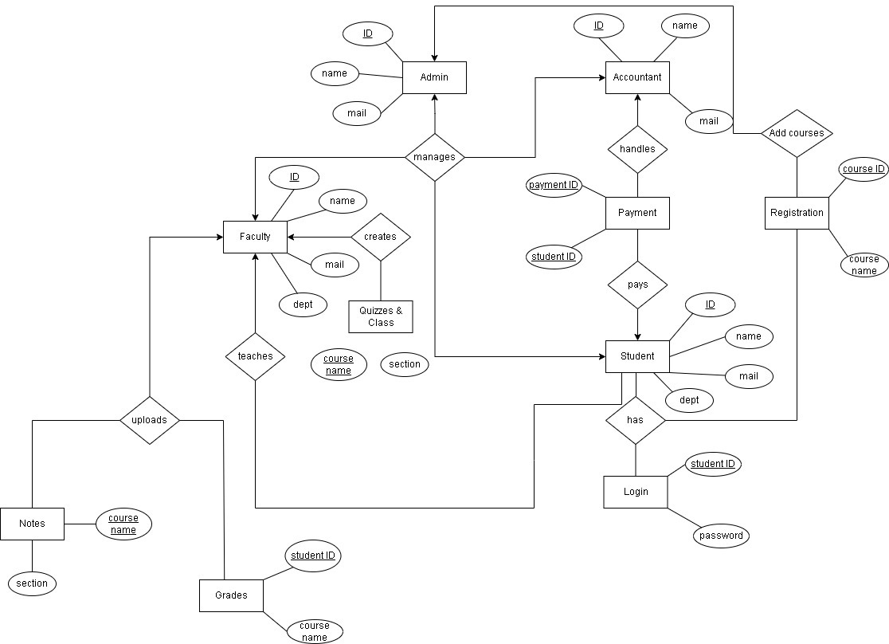

The entity relationship between each user in this system is shown by the ER diagram. Each user has unique characteristics. The faculty has the ability to design classes and courses with unique characteristics. They can upload grades as well. A student can access their account and attend classes by logging in. They are able to register for classes and give feedback. The accountant will handle their semester fees, which they can pay. The entire system must be managed by the admin.

**Use-case Diagram:**

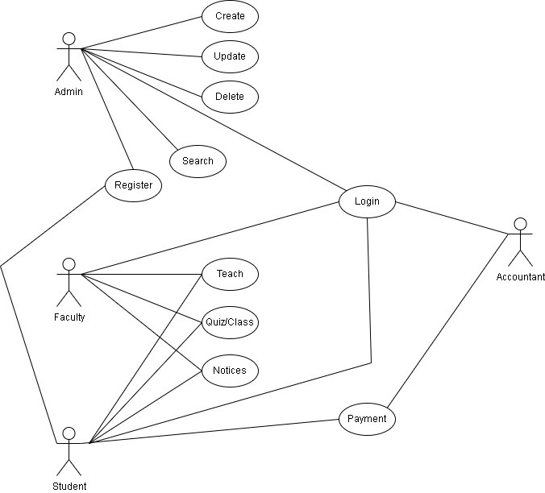

The use case details every feature of each and every system user. The entire system must be managed by the administrator. This includes hiring any new pupils or staff. He can also change their data. and conduct a search. The administrator may permit students to register for classes. Students are taught by faculty members by giving them access to their particular classes. They can also give the pupils homework and tests. Notices may also be given by the faculty. The student has access to take part in classes, quizzes, assignments, and view the published notices. They can also provide feedback on individual faculties. The student can pay their fees through any of their convenient methods. The organization's finance and accounts division are managed by the accountant.

**Activity Diagram:**

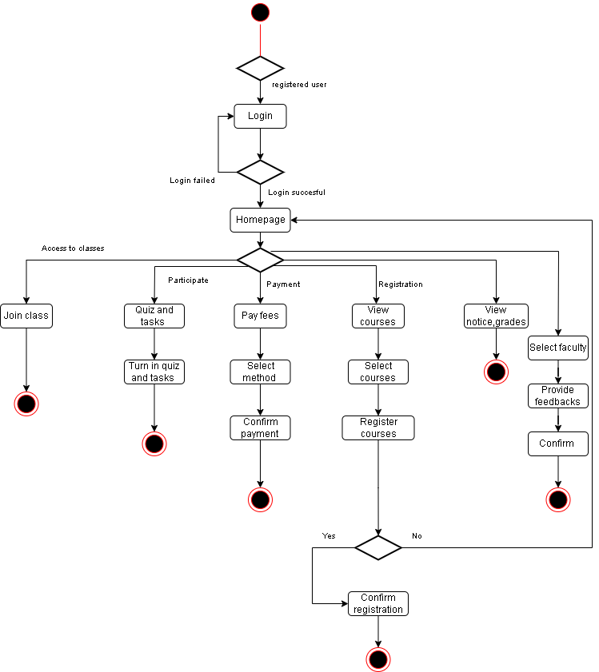

To complete their tasks, the student must log into the system. The homepage won't show up until after a successful login. If not, the incorrect credentials will appear. The aforementioned actions will be taken after login into the student account. They can enroll in classes at any time. They can also take part in projects and quizzes. This portal makes it simple to register for courses. The student can pay their semester fees online by selecting their convenient payment methods and finally confirm the payment. They can also view their grades and published notices. Every student has the ability to submit feedback.

**3.** **SOCIAL IMPACT**

The majority of academies in our country do not use a management system. As a result, they face trouble with data handling. It is possible, however, to avoid this type of scenario if the academy implements a management system, such as the one we are proposing. Aside from this pandemic situation, institutions using management software would benefit their employees. This is because they will be able to handle many tasks simultaneously, such as handling admissions, managing student data, managing accounts, and so on. By using the system alongside real-life experiences, the institution can provide improved services to its students, which will have a profound effect on our education system as a whole.

**4.** **DEVELOPMENT PLAN WITH PROJECT SCHEDULE**

**SDLC STAGES:**

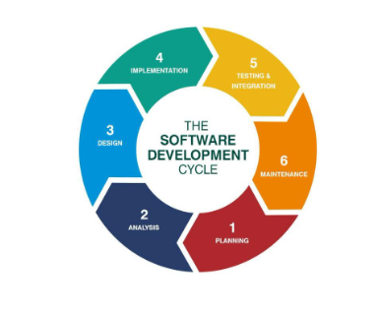

**Stage 1:** Planning and Requirement Analysis is the most important and fundamental stage in SDLC. It will be performed by the senior members of the team with inputs from the customer, the sales department, market surveys, and domain experts in the industry.

**Stage 2:** Defining Requirements Once the requirement analysis is done the next step will be to clearly define and document the product requirements and get them approved by the customer or the market analysts. This will be done through an SRS (Software Requirement Specification)

**Stage 3:** Designing the Product Architecture SRS is the reference for product architects to come out with the best architecture for the product to be developed. Based on the requirements specified in SRS, usually, more than one design approach for the product architecture is proposed and documented in a DDS -Design Document Specification.

**Stage 4:** Building or Developing the Product In this stage of SDLC the actual development will start and the product will be built. The programming code is generated as per DDS during this stage

**Stage 5:** Testing the Product This stage will be a subset of all the stages as, in the modern SDLC models, the testing activities are mostly involved in all the stages of SDLC.

**Stage 6:** Deployment in the Market and Maintenance

Once the product is tested and ready to be deployed it will be released formally in the appropriate market.

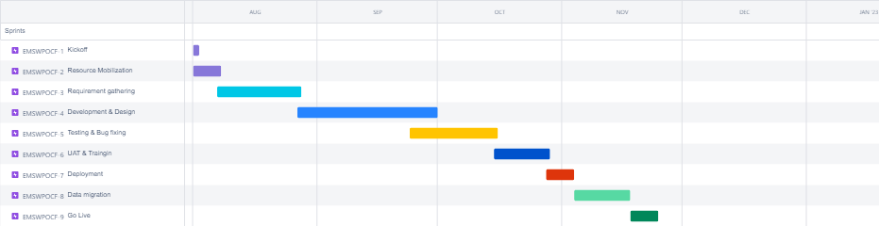

For our project, we used a hybrid methodology that combines the agile and waterfall models. The first week saw the mobilization of resources. The following iteration lasted for three weeks, during which we gathered all the requirements. The next four weeks of iteration were spent developing and designing. In the agile methodology, which includes a three-week iteration, testing and bug fixes have already begun. There was a two-week iteration of UAT following the testing of the bug. After one week's worth of iterations, the deployment has begun. Data migration underwent a two-week iteration immediately which was followed by deployment. Finally, the project goes live.

**5.** **MARKETING PLAN**

It is critical for us to develop a corporate identity for our education consultancy that will help boost brand awareness. As a result, our sales and marketing teams will be based on their extensive industry experience. Regular training will ensure that they are well-prepared to meet both their targets and the organization's overall goals. Following marketing and sales strategies to attract prospective students;

* Send introductory letters with our brochure to foreign educational institutions in order to introduce our education consulting firm business.
* Advertise our business in relevant magazines, newspapers, TV stations, and radio stations.
* Encourage the use of word-of-mouth publicity from our loyal and satisfied students organizing and conducting business expos, seminars, and business fairs
* To promote the company using the internet and social media platforms, such as YouTube, Instagram, Facebook, Twitter, LinkedIn, Google+, and other platforms, and engaging in direct marketing strategies. To ensure that our banners and billboards are strategically placed in various cities of Bangladesh.
* Distribution of fliers in our neighborhood and local areas
* Ensure that our official website is well advertised and use strategies to attract traffic to it.

**6.** **COST AND PROFIT ANALYSIS**

**Average Cost per Man day:**

|  |  |
| --- | --- |
| **Roles** | **BDT/Man Day** |
| Project Manager | 14,000 |
| Business Analyst | 12,000 |
| System Analyst | 12,000 |
| Tech Team Lead | 12,000 |
| Senior Developer | 10,000 |
| Developer | 8,000 |
| SQA | 9,000 |
| Database admin and Trainer | 9,000 |
| **Average** | **10,750** |

**Total Cost:**

The project duration is 4 months means 88 working days.

|  |  |
| --- | --- |
| **Category** | **Cost** |
| Total cost of man days | (10,750*88) = 9,46,000 |
| Others cost | 1,30,000 |
| Final Cost(without vat) = | **10,76,000** |
| Vat (5%) | 53,800 |
| **Final Cost of the project** | **11,29,800** |

**In-house costing estimation:**

|  |  |
| --- | --- |
| **Roles** | **BDT/Man Day** |
| Project Manager | 10,000 |
| Business Analyst | 8,000 |
| System Analyst | 9,000 |
| Tech Team Lead | 8,000 |
| Fronted Developer | 6,000 |
| Backend Developer | 6,000 |
| Mobile Application Developer | 6,000 |
| SQA | 6,000 |
| Database admin and Trainer | 6,000 |
| **Average (in house)** | **8,125** |

**Average Man days(in house):**

|  |  |
| --- | --- |
| **Roles** | **Man days** |
| Project Manager | 88 days |
| Business Analyst | 44 days |
| System Analyst | 22 days |
| Tech Team Lead | 30 days |
| Fronted Developer | 44 days |
| Backend Developer | 88 days |
| Mobile Application Developer | 60 days |
| SQA | 44 days |
| Database admin and Trainer | 44 days |
| **Average (in-house)** | **52 days** |

**Total Costing (in-house):**

|  |  |
| --- | --- |
| **Category** | **Cost** |
| Total cost | (8,125*52) = 4,22,500 |
| Others cost(utility) | 1,10,000 |
| **Final Cost** | **5,32,500** |

**Revenue:**

**Final Cost(without vat for client) - Final cost(for in-house)**

=**10,76,000** **- 5,32,500**

**= 5,43,500**

**So the total profit in this project will be 5,43,500 BDT.**

**7.** **REFERENCE**

<https://www.microsoft.com/en/microsoft-teams/log-in>

<https://meet.google.com/>

<https://igradeplus.com/>

<https://www.aiub.edu/>